Luxury Meets the Stage: Lexus and the King Center Announce Exclusive Partnership

THURSDAY, FEBRUARY 15 MELBOURNE, FL –
The King Center for the Performing Arts with ASM Global is proud to announce a new collaboration with Lexus, marking a new era of elegance and sophistication in the realm of arts and entertainment on the Space Coast.

In this groundbreaking endeavor, Lexus becomes the “Official Vehicle of the King Center for the Performing Arts,” solidifying its commitment to excellence and innovation in the arts community. The Lexus brand epitomizes luxury, craftsmanship, and unparalleled performance -qualities that mirror the world-class entertainment and experiences offered at the King Center.

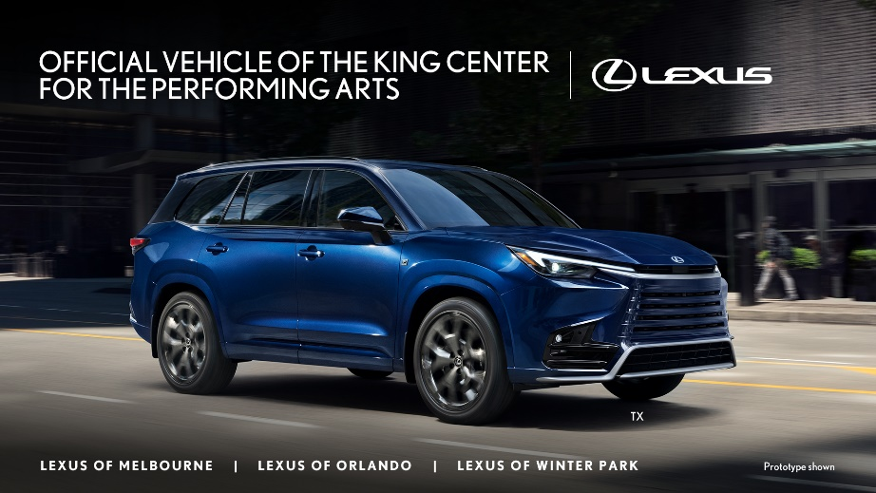
As part of this partnership, King Center guests will enjoy the newly rebranded Lexus Lounge at the Crown Club, providing members with an elevated pre-show experience with best-in-class amenities. For more information on becoming a King Center member with access to the Lexus Lounge at the Crown Club, visit www.KingCenter.com.

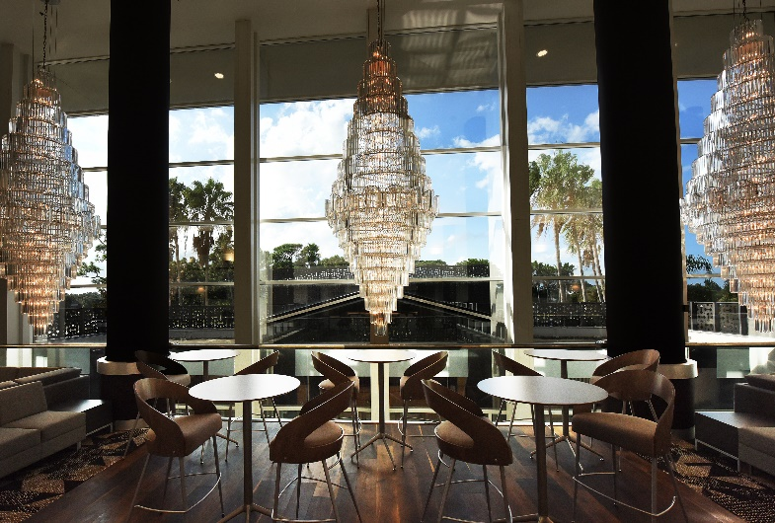
“We are pleased to welcome Lexus as our Official Vehicle Partner and are looking forward to the many benefits our community will enjoy from our partnership, including the Lexus Lounge at the Crown Club” said Bob Papke, Vice President, ASM Global, and General Manager of the King Center. “This collaboration represents two brands dedicated to delivering unparalleled experiences and fostering a culturally rich community here on the Space Coast. We look forward to creating unforgettable memories for our patrons together.”

“Lexus strives to create memorable experiences for our guests, and this exciting endeavor with the King Center will do just that,” said Sam Wintermyer, General Manager, Lexus Southern Area. “We look forward to welcoming everyone to the Lexus Lounge at the Crown Club and continuing to support the King Center’s mission to bring high-quality, diverse performing arts to the community.”

The partnership between Lexus and the King Center is a testament to their shared values of excellence, innovation, and community engagement. Together, they will continue to enrich the cultural landscape and create memorable experiences for guests for years to come.

Stay up to date on all King Center Announcements & Happenings!
Sign up to receive e-mail alerts and announcements

Follow Social Media:
Facebook: @King.Center
facebook.com/king.center

Instagram: @KingCenterMelbourne
instagram.com/kingcentermelbourne/

About Maxwell C. King Center for The Performing Arts
The Maxwell C. King Center for The Performing Arts, a proud direct support organization of Eastern Florida State College and ASM Global managed venue, has been at the heart of cultural and educational experiences since 1988. The six-story, 100,000-square foot facility has continuously dedicated itself to curating outstanding educational, cultural, and community events that resonate with audiences of all backgrounds. From the acoustically brilliant L3Harris Technologies Theatre, boasting 2,016 seats, to the intimate 300-seat Studio Theatre and the exclusive Crown Club VIP room, the King Center offers a symphony of spaces that cater to diverse events and occasions, making it a vibrant hub for artistic expression and community engagement.

Mission Statement: To improve the quality of life for all residents of Brevard County through cultural, educational, recreational and community arts programs, by providing access to high quality, challenging and diverse touring and local performing arts events.

About ASM Global
ASM Global is the world’s leading producer of entertainment experiences. It is the global leader in venue and event strategy and management—delivering locally tailored solutions and cutting-edge technologies to achieve maximum results for venue owners. The company’s elite venue network spans five continents, with a portfolio of more than 350 of the world’s most prestigious arenas, stadiums, convention and exhibition centers, and performing arts venues. Follow us on Facebook, Instagram, LinkedIn, and Twitter. asmglobal.com

About Lexus
Lexus' passion for brave design, imaginative technology, and exhilarating performance enables the luxury lifestyle brand to create amazing experiences for its customers. Lexus began its journey in 1989 with two luxury sedans and a commitment to pursue perfection. Since then, Lexus has developed its lineup to meet the needs of global luxury customers in more than 90 countries. In the United States, Lexus vehicles are sold through 244 dealers offering a full lineup of luxury vehicles. With eight models incorporating Lexus Hybrid Drive, Lexus is the luxury hybrid leader. Lexus also offers nine F SPORT models, one F performance model and one F model. Lexus is committed to being a visionary brand that anticipates the future for luxury customers.
www.facebook.com/lexus
www.twitter.com/lexus
www.youtube.com/LexusVehicles
www.instagram.com/lexususa
https://www.pinterest.com/lexususa

